**Abstract**

Home automation is one of the major growing industries that can change the way people live. Some of these home automation systems target those seeking luxury and sophisticated home automation platforms, others target those with special needs like the elderly and the disabled. Typical wireless home automation system allows one to control house hold appliances from a centralized control unit which is wireless. These appliances usually have to be specially designed to be compatible with each other and with the control unit for most commercially available home automation systems. The developed system can be integrated as a single portable unit and allows one to wirelessly control lights, fans. air conditioners, television sets. security cameras, electronic doors, computer systems.

audio/visual equipments etc. and turn ON or OFF any appliance that is plugged into a wall outlet, get the status of different sensors and take decision accordingly. The system is portable and constructed in a way that is easy to install.

configure, run, and maintain. The perfect user interface still does not exist at present and to build a good interface requires knowledge of both sociology and technology fields. According to major companies that are involved in speech recognition researches, voice will be the primary interface between humans and machines in the near future. The problem lies with the situation of the elderly or disabled people, who cannot usually help themselves to move around, and might require external assistance. People who live alone might also need a helping hand at home. Therefore a voice controlled home automation system is designed, so that the users can perform certain tasks by just the use of their voices, moreover, the system is designed to have a hand-held device(remote) so that the user can easily speak their commands, otherwise they would have to walk over to the microphone to speak. Having a remote will make the system more user-friendly and portable.

TABLE OF CONTENTS

Ccertificate 2

Acknowledgement 3

Abstract 4

Table of Contents 5

CHAPTER I: INTRODUCTION 6

1.1 PROBLEM DESCRIPTION: 7

1.2 PROJECT AIM 8

CHAPTER 2: REQUIREMENT

2.1 HARDWARE REQUIREMENT 9

2.2 SOFTWARE REQUIREMENT 10

CHAPTER 3 IOT

3.1 WHAT IS IOT? 10

3.2 HOW IOT WORKS? 11

3.3 WHY IOT IS IMPORTANT 11

CHAPTER 4: SMART HOME

4.1 WHAT IS A SMART HOME? 12

4.2 WHAT CAN A SMART HOME DO ? 12

CHAPTER 5: HARDWARE USED

5.1 ARDUNO UNO 13

5.2 ULTRASONIC SENSOR 14

5.3 SERVO MOTOR 15

5.4 CIRCUIT DIAGRAM 16

CHAPTER 6: CODE 17

CHAPTER 7: USE CASES : 20

7.1 PROS & CONS 23

7.2 APPLICATION 24

7.3 FUTURE ASPECTS 27

CONCLUSION 31

REFERENCES 28

1. ***INTRODUCTION:***

Home automation is anything that enables you to use your home’s lighting, heating and appliances more conveniently and efficiently.

Nowadays, we have remote controls for our television sets and other electronic systems, which have made our lives real easy. Have you ever wondered about home automation which would give the facility of controlling tube lights, fans and other electrical appliances at home using a remote control? Off-course, Yes! But, are the available options cost-effective? If the answer is No, we have found a solution to it. We have come up with a new system called Arduino based home automation using Wifi. This system is super-cost effective and can give the user, the ability to control any electronic device without even spending for a remote control. This project helps the user to control all the electronic devices using his/her smartphone.

Time is a very valuable thing. Everybody wants to save time as much as they can. New technologies are being introduced to save our time. To save people’s time we are introducing Home Automation system using WIFI. With the help of this system you can control your home appliances from your mobile phone. You can turn on/off your home appliances within the range of WIFI.

***1.1 PROBLEM DESCRIPTION:***

Many home devices now have WIFI and can interact with other home devices, smartphone applications and home computers. An issue is that these devices cannot communicate with each other or require an additional device to do so and need an individual application on the smartphone to be controlled. A much better option is to unify these devices into one program/device that controls them. As an example, one can control the lights, microwave, oven, tv, air-conditioning and door locks through one application on the smartphone. This gives the consumer more control of their home, for example, it allows them to set up conditions for when the lights turn on, or if they are on their way home, to preheat the oven before they get home. Therefore, home automation can simplify many manual actions.

***1.2 PROJECT AIM:***

The aim of the project is to design and construct a home automation system that will remotely switch on or off any household appliances connected to it, using a microcontroller, keypad or WIFI based application.

1. ***OBJECTIVE:***

One home automation application that has recently started to become mainstream is the ability to control door locks using a smartphone application or through the internet (web application). This project aims to develop a prototype of a product capable of locking/unlocking a door, with an emphasis on low cost and open source configurability. The end goal beyond this project would be a product that would hopefully allow people to connect to many other home devices through WiFi.

***2.1 HARDWARE REQUIREMENT***

* **Automatic Light**
* Node MCU with ESP8266
* Led
* Bread Board
* Connecting wire
* **Automatic Door**
* Arduino Uno
* Ultrasonic Sensor
* 12 V dc Servo motor
* Led
* Bread Board
* Connecting wire
* **Security Door**
* Arduino Uno
* Analog Keypad
* 12 V Dc Servo motor
* Led
* 4XAA Battery
* Bread board
* Connecting wire

**Temperature and Humidity Sensor**

DHT22 temp sensor

Arduino Uno

***2.2 SOFTWARE REQUIREMENT:***

* Arduino IDE
* Blynk Cloud Platform

***3.1 WHAT IS IOT?***

The internet of things, or IoT, is a system of interrelated computing devices, mechanical and digital machines, objects, animals or people that are provided with unique identifiers ([UIDs](https://internetofthingsagenda.techtarget.com/definition/unique-identifier-UID)) and the ability to transfer data over a network without requiring human-to-human or human-to-computer interaction.

A THING in the internet of things can be a person with a heart monitor implant, a farm animal with a biochip transponder, an automobile that has built-in sensor to alert the driver when tire pressure is low or any other natural or man-made object that can be assigned an IP address and is able to transfer data over a network.

Increasingly, organizations in a variety of industries are using IoT to operate more efficiently, better understand customers to deliver enhanced customer service, improve decision-making and increase the value of the business.

***3.2 HOW IOT WORKS?***

A thing in the internet of things can be a person with a heart monitor implant, a farm animal with a biochip transponder, an automobile that has built-in sensors to alert the driver when tire pressure is low or any other natural or man-made object that can be assigned an IP address and is able to transfer data over a network.

Increasingly, organizations in a variety of industries are using IoT to operate more efficiently, better understand customers to deliver enhanced customer service, improve decision-making and increase the value of the business.

***3.3 WHY IOT IS IMPORTANT:***

The internet of things helps people live and work smarter as well as gain complete control over their lives. In addition to offering smart devices to automate homes, IoT is essential to business. IoT provides businesses with a real-time look into how their companies’ systems really work, delivering insights into everything from the performance of machines to supply chain and logistics operations.

IoT enables companies to automate processes and reduce labor costs. It also cuts down on waste and improves service delivery, making it less expensive to manufacture and deliver goods as well as offering transparency into customer transactions.

IoT touches every industry, including healthcare, finance, retail and manufacturing. Smart cities help citizens reduce waste and energy consumption and connected sensors are even used in farming to help monitor crop and cattle yields and predict growth patterns.

As such, IoT is one of the most important technologies of everyday life and it will continue to pick up steam as more businesses realize the potential of connected devices to keep them competitive.

***BENEFITS OF IOT***

The internet of things offers a number of benefits to organizations, enabling them to:

* Monitor their overall business processes;
* Improve the customer experience;
* Save time and money;
* Enhance employee productivity;
* Integrate and adapt business models;
* Make better business decisions; and
* Generate more revenue.

4.1 ***WHAT IS A SMART HOME?***

The term [**'smart home'**](https://www.shop.bt.com/smarthome/?ReferrerID=G600&utm_source=btcom&utm_medium=bt+marketing&utm_campaign=smart+home+article111017&utm_content=G600) is used to describe a house that contains a communication network that connects different appliances and allows them to be remotely controlled, monitored and accessed, according to the [**Department of Trade and Industry**](https://www.housinglin.org.uk/_assets/Resources/Housing/Housing_advice/Smart_Home_-_A_definition_September_2003.pdf)**.**

Smart devices connect to the internet and many have smartphone apps allowing you to access and control them remotely over [wi-fi.](https://www.productsandservices.bt.com/broadband/upgrade/?s_intcid=con_intban_dmedia_content_q4_broadband_recon_smarthome)

It’s becoming easier to connect an entire home too. Broadband is faster, more reliable and more affordable than ever before. The improved signal range of Wi-Fi routers means that a single router can offer wireless coverage across more rooms in our homes, allowing more devices to be connected.

What's more, low-priced networking equipment has made it cheaper to extend home networks into rooms that were difficult to cover using just a single Wi-Fi router. Even previously difficult properties, such as older homes with thick walls, can now benefit from a home network that covers the entire property.

***4.2 WHAT CAN A SMART HOME DO ?***

Using the technology within the house, you can control and see what is going on in your home, even when you’re not there using a smartphone, tablet or sometimes computer. For instance, if you’ve just got a couple of brand new puppies and want to ensure they’re behaving themselves, you can install a home camera that allows you to check in on your pets whenever you want

There is also the potential to make a big difference in the cost of your utility bills, as now there’s no need to burn money by forgetting to turn the heating off when you leave for work. By monitoring your heating, water and electricity, there’s far less chance of a large bill sneaking up on you.

Smart homes can also protect the most vulnerable in society. Some devices can trigger an alert if an elderly person fails to take their pills, falls over or is behaving outside their normal routine. The University of Surrey has created[**'living labs'**](http://www.sabp.nhs.uk/tihm/about) to test how this technology would help people with dementia.

***5.1 ARDUNO UNO :***

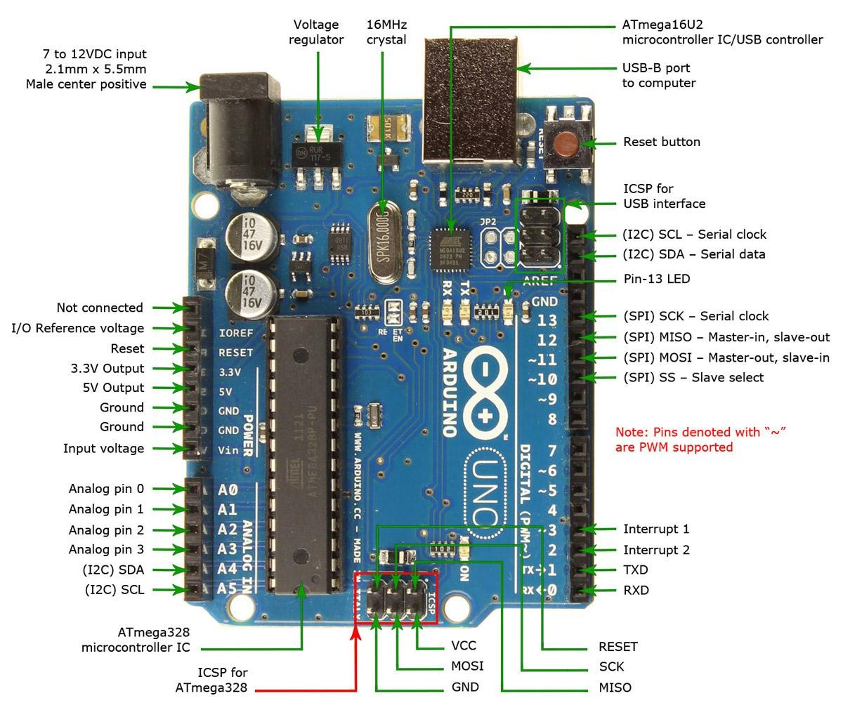

The Arduino Uno is a microcontroller board based on the ATmega328P . It has 14 digital input/output pins (of which 6 can be used as PWM outputs), 6 analog inputs, a 16 MHz crystal oscillator, a USB connection, a power jack, an ICSP header, and a reset button. It contains everything needed to support the microcontroller; simply connect it to a computer with a USB cable or power it with a AC-to-DC adapter or battery to get started.

The Uno differs from all preceding boards in that it does not use the FTDI USB-to serial driver chip. Instead, it features the Atmega8U2 programmed as a USB-to serial converter.

➢ Some Technical Specification of Arduino Uno are:

1. Microcontroller ATmega328P
2. Operating Voltage 5V
3. Input Voltage (recommended) 7-12V
4. Input Voltage (limits) 6-20V
5. Digital I/O Pins 14
6. Analog Input Pins 6
7. DC Current per I/O Pin 40 mA
8. DC Current for 3.3V Pin 50 mA
9. Flash Memory 32 KB of which 0.5 KB

used by bootloader

1. SRAM 2 KB
2. EEPROM 1 KB
3. Clock Speed 16 MHz

***5.2 ULTRASONIC SENSOR:***

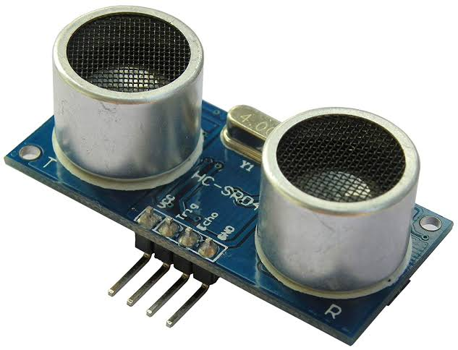

**Ultrasonic sensors** work by emitting sound waves at a frequency too high for humans to hear. They then wait for the sound to be reflected back, calculating distance based on the time required. This is similar to how radar measures the time it takes a radio wave to return after hitting an object

How Do **Water Sensors Work**? A **water sensor** can detect the presence of **water**, often by measuring the electrical conductivity of the **water** present and completing a circuit to send a signal. ... Some **water sensor** systems can be programmed to shut off the **water** to the house to prevent a small leak from becoming a large one.

***5.3 SERVO MOTOR***



A **servo motor** is an electrical device which can push or rotate an object with great precision. If you want to rotate and object at some specific angles or distance, then you use servo motor. It is just made up of simple motor which run through **servo mechanism**. If motor is used is DC powered then it is called DC servo motor, and if it is AC powered motor then it is called AC servo motor. We can get a very high torque servo motor in a small and light weight packages. Doe to these features they are being used in many applications like toy car, RC helicopters and planes, Robotics, Machine etc.

It consists of three parts:

1. Controlled device
2. Output sensor
3. Feedback system

A servo consists of a Motor (DC or AC), a potentiometer, gear assembly and a controlling circuit. First of all we use gear assembly to reduce RPM and to increase torque of motor. Say at initial position of servo motor shaft, the position of the potentiometer knob is such that there is no electrical signal generated at the output port of the potentiometer. Now an electrical signal is given to another input terminal of the error detector amplifier. Now difference between these two signals, one comes from potentiometer and another comes from other source, will be processed in feedback mechanism and output will be provided in term of error signal. This error signal acts as the input for motor and motor starts rotating. Now motor shaft is connected with potentiometer and as motor rotates so the potentiometer and it will generate a signal. So as the potentiometer’s angular position changes, its output feedback signal changes. After sometime the position of potentiometer reaches at a position that the output of potentiometer is same as external signal provided. At this condition, there will be no output signal from the amplifier to the motor input as there is no difference between external applied signal and the signal generated at potentiometer, and in this situation motor stops rotating.

***5.4 CIRCUIT DIAGRAM FOR AUTOMATIC LIGHT IN A SMART HOME***

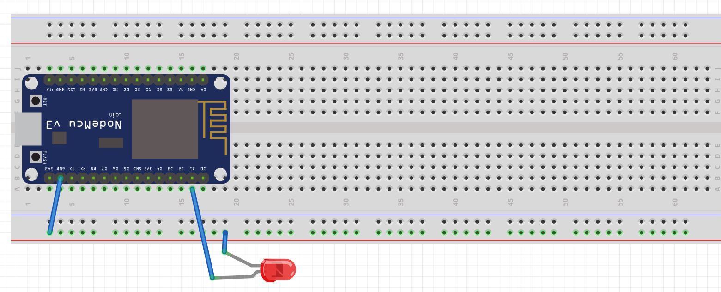

***REQUIRED CODE FOR AUTOMATIC LIGHT***

***#define BLYNK_PRINT Serial***

***#include <ESP8266WiFi.h>***

***#include <BlynkSimpleEsp8266.h>***

***// We should get Auth Token in the Blynk App.***

***// Go to the Project Settings (nut icon).***

***char auth[] = "A1KfQb9-vLYn6yJ2xfKPfJxK0bT3DFX3";***

***// Your WiFi credentials.***

***// Set password to "" for open networks.***

***char ssid[] = "Sanglap";***

***char pass[] = "EEE1707046";***

***void setup()***

***{***

***// Debug console***

***Serial.begin(9600);***

***Blynk.begin(auth, ssid, pass);***

***}***

***void loop()***

***{***

***Blynk.run();***

***}***

***CIRCUIT DIAGRAM FOR AUTOMATIC DOOR :***

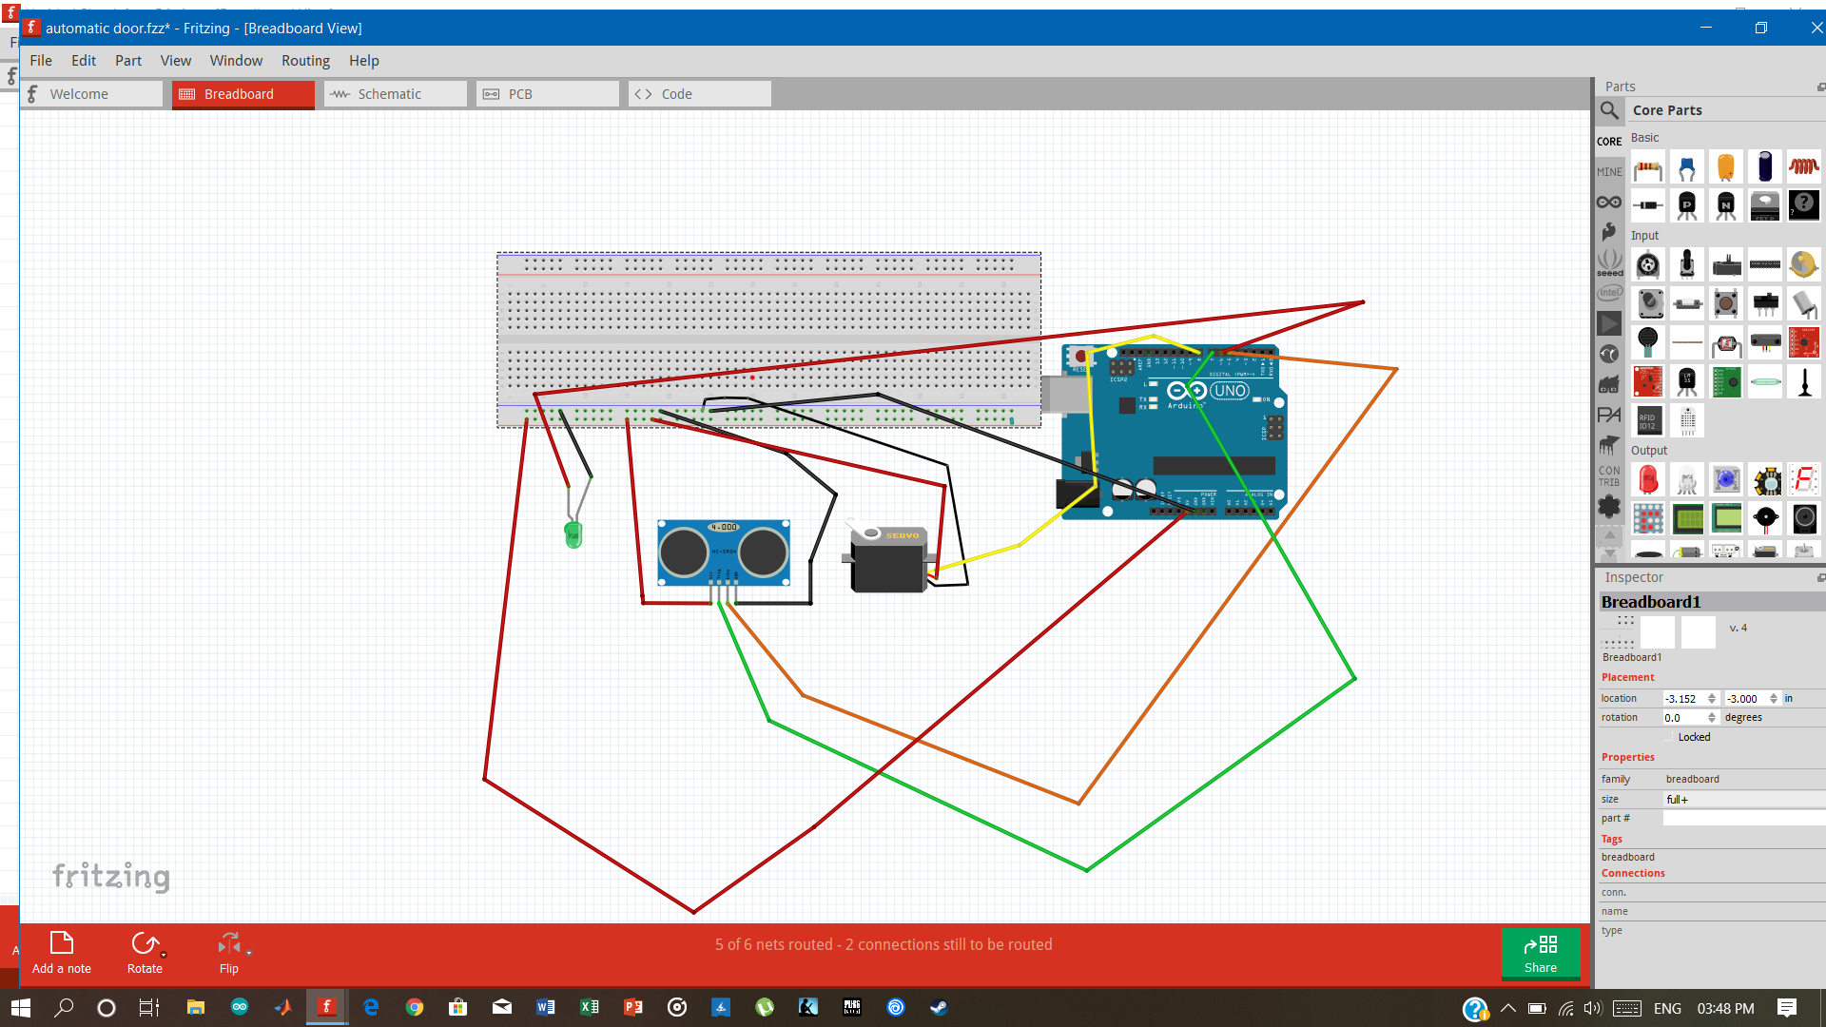

***REQUIRED CODE FOR AUTOMATIC DOOR:***

1. #include<Servo.h>
2. Servo x;
3. int pos = 0;// intialized position as 0;
4. const int y=5;//echo pin of sonar1;
5. const int z=7;//trigger pin of sonar1;
6. void setup()
7. { pinMode(6,OUTPUT);//LED LIGHT;
8. x.attach(8);//SERVO MOTOR ;
9. pinMode(z,OUTPUT);// trigger is for output signal;
10. pinMode(y,INPUT);//echo for input signal;
11. }
12. void loop()
13. {
14. long d;//duration
15. int s;//distance
16. digitalWrite(z,LOW);// At initial trigger is 0;
17. delayMicroseconds(2);// after the first stage timer need a delay of 2 microseconds;
18. digitalWrite(z,HIGH);// now the trigger is switched on;
19. delayMicroseconds(5);// delay of 5 microseconds ;
20. d=pulseIn(y,HIGH);// Sonar sensor Take pulses(Signal) from the object;
21. s=d*0.034/2;//Mesure the distance by using Dopller effect of sound;
22. if(s<=40)//when distance is less then 4 cm;
23. {
24. for(pos=0; pos<=130;pos+=5)// gate is opened ;
25. {
26. x.write(pos);
27. digitalWrite(6,HIGH);//gate opened and the led turned on;
28. delay(5);
29. }delay(10000);}
30. else
31. {
32. for(pos=130;pos>=0;pos-=5);//gate is closed;
33. {
34. x.write(pos);
35. digitalWrite(6,LOW);
36. delay(20);
37. }
38. }delay(100);}

***CIRCUIT DIAGRAM FOR SEQURITY FRONT DOOR :***

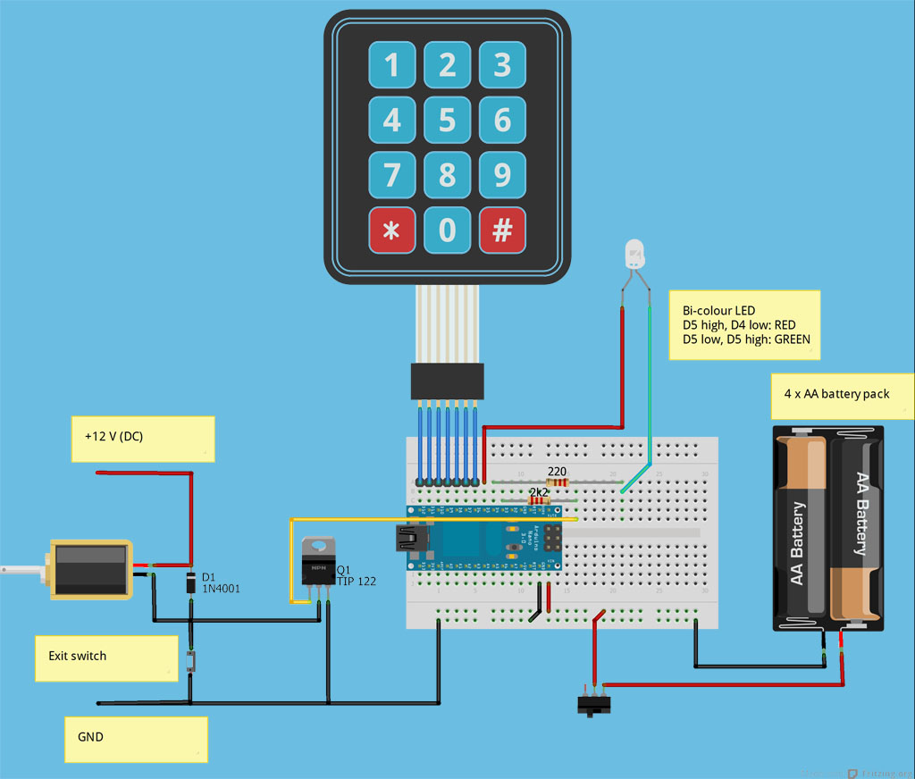

**Temperature and Humidity Sensor**

The DHT22 is a basic, low-cost digital temperature and humidity sensor. It uses a capacitive humidity sensor and a thermistor to measure the surrounding air, and spits out a digital signal on the data pin (no analog input pins needed). It's fairly simple to use, but requires careful timing to grab data.

This sensor is used in various applications such as measuring humidity and temperature values in heating, ventilation and air conditioning systems. Weather stations also use these sensors to predict weather conditions. The humidity sensor is used as a preventive measure in homes where people are affected by humidity.

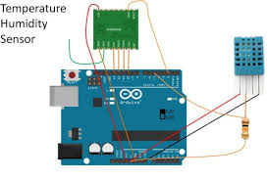

***7.1 PROS OF HOME AUTOMATION :***

## 1. Security

Tap your finger to turn on the lights when you get home so you worried about what’s hiding in the shadows, or in your pathways. Or automate to turn on when you aren’t home to look like you are to ward off potential robbers. Door locks are another automated home product that can increase your home security.

## 2. Energy Efficiency

Increase your home’s energy efficiency by remotely powering off systems and appliances when they aren’t in use. In addition to the standard home automation products that give you active control, some products actively monitor systems and arm the homeowner with knowledge, insight and guidance to achieve greater control and energy efficiency.

## 3. Savings

Home automation literally pays off. When you are able to use home systems and appliances only when needed, the savings will be apparent in the first utility bill. No more wasting money on lights left on when you aren’t home, or spending money on gas to drive home because you forgot to lock the door. Monetary savings are apparent, but you’ll also be saving time. No wasted trips home, no running through the house turning everything off, no time spent worrying about what was or wasn’t turned off.

## 4. Convenience

Don’t you hate having to rely on neighbours to watch your house when you’re gone? With home automation, convenient control of your home is at your fingertips. You don’t have to trust someone else with your most valued possessions.

## 5. Comfort

Ever leave for work in the morning when it was a comfortable 68° outside only to come home to a sweltering house because the temperature shot up to 90°? Connected home products like the Sensi Wi-Fi Thermostats let you conveniently adjust your home temperature from the mobile app so your family is always comfortable.

***7.2 CONS OF HOME AUTOMATION:***

## 1. Cost of Intelligence

Installing state-of-the-art features inside a home results in a higher price tag for the property. The cost of an intelligent home that makes our lives convenient is high because some of the technology is relatively new. The cost of living expenses such as utilities, maintenance and repair of the technology can be expensive as well.

## 2. Technology Learning Curve

Owning a smart home means having to learn how to use your home. Unlike traditional homes, smart home technology requires you to adapt to the innovations within your living area such as security systems, air units and a remote that controls your entire house. For the technology-savvy family, the smart home will help achieve convenience faster, but for others, it will take reading manuals and learning how-to before the benefits of convenience pay off.

## 3. Video Surveillance

Video surveillance can be a wonderful tool in heightening security and deterring crime, but when the technology falls into the wrong hands, issues of privacy can occur. Security sensors within the doors and walls of a smart home use wireless technology to transfer signals to a central control unit that notifies emergency officials of any foreign activity.

***7.3 APPLICATION***

* Using this project, we can turn on or off appliances remotely i.e. using a phone or tablet.
* The project can be further expanded to a smart home automation system by including some sensors like light sensors, temperature sensors, safety sensors etc. and automatically adjust different parameters like room lighting, air conditioning (room temperature), door locks etc. and transmit the information to our phone.
* Additionally, we can connect to internet and control the home from remote location over internet and also monitor the safety.

***Future Aspects-***

Home of the future is a space for the digital natives. With the invention of lots of automation technologies featuring IOT and AI, home automation has become a reality. One can implement several of their tasks with just a single command of verbal instructions. These technologies can used to build fully functional home automation system and control smart home devices including smart lights, connected thermostats, and appliances.

There are several new technologies which can become a part of home in the near future:

**Increased efficiency, control, and customization**: Artificial intelligence is set to make you lazy in the near future. Technology will become much more efficient and one will be able to control everything from volume to security from one central place. The devices will work automatically and you don’t need to waste your energy it will act upon user’s preferences. AI would revolutionize home by automatic threat detection and proactive alertness.

**Integration of Smart home devices**: One can command it to control small things of home through voice and Smartphones. All the tech giants are working in the field of IoT to bring advancements in the home automation devices. In near future, homes will be equipped with such IoT devices which will make your daily lives work faster smoother and more accurate.  
Mark Zuckerberg came up with a goofy proof-of-concept video showing off an idealized version of how his Jarvis system actually works. Google Home, which is Google’s smart speaker loaded with Google Assistant, was updated at last year’s Google I/O with a bunch of new features, including “proactive assistance”, also known as push notifications, hands-free free calling, Spotify, SoundCloud, and Deezer integrations, and more. Also, more recently, Google launched two more Google Home speakers, Home Max and Home Mini.

**Smart spaces outside homes**: Smart parking through sensors will help to recognize whether the parking is available or not. Camera monitoring can be done and with the help of artificial intelligence and computer vision, both parking facilities and security can be provided. It would be a faster and smoother process and act as a reference for other smart systems to be build accordingly. Streetlights can also be automated through sensors and build for effective use for the people nearby.

**Development of smart appliances**: The devices which we use to use like television, refrigerator and even the mirror is getting smarter today with evolution of technology. The smart mirror should not only act as a face video but also help to other tasks like listening to music and stuff. Televisions have become part of a centralized entertainment and can also be used for social media. The refrigerator has been upgraded to sense the temperature outside and operate accordingly. The washing machine will wash the clothes according to the clothes material and switch off after drying. They will keep on advancing as the technology evolves.

**Personal home delivery**: Drones will be used to deliver the packages at the right time. They will replace the normal salesman job. They might also be used for several other tasks like monitoring the weather outside the home, returning something back to a relative’s home nearby and so on. They can also be used for monitoring the traffic in our locality.

One can build several amazing projects using the concepts of home automation.

***CONCLUSION:***

The home automation system has been experimentally proven to work satisfactorily by connecting sample appliances to it and the appliances were successfully controlled from a wireless mobile device. We learned many skills such as soldering, wiring the circuit and other tools that we use for this project and was able to work together as a team during this project. The Wifi client was successfully tested on a multitude of different mobile phones from different manufacturers, thus proving its portability and wide compatibility. Thus a low-cost home automation system was successfully designed, implemented and tested.